//iperf3 is used to diagnose network speed.

iperf3 -s // s indicates server.

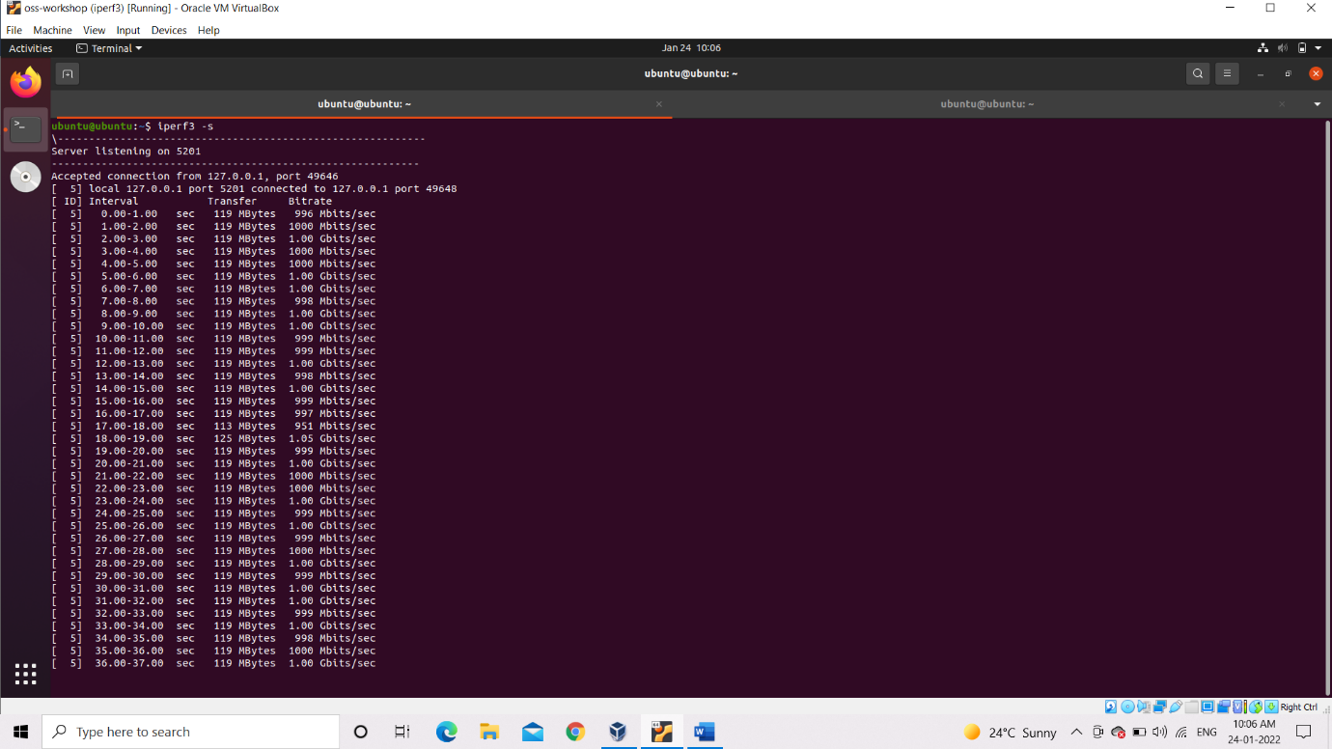

iperf3 -c 127.0.0.1 -t 600 -b 1G -i2

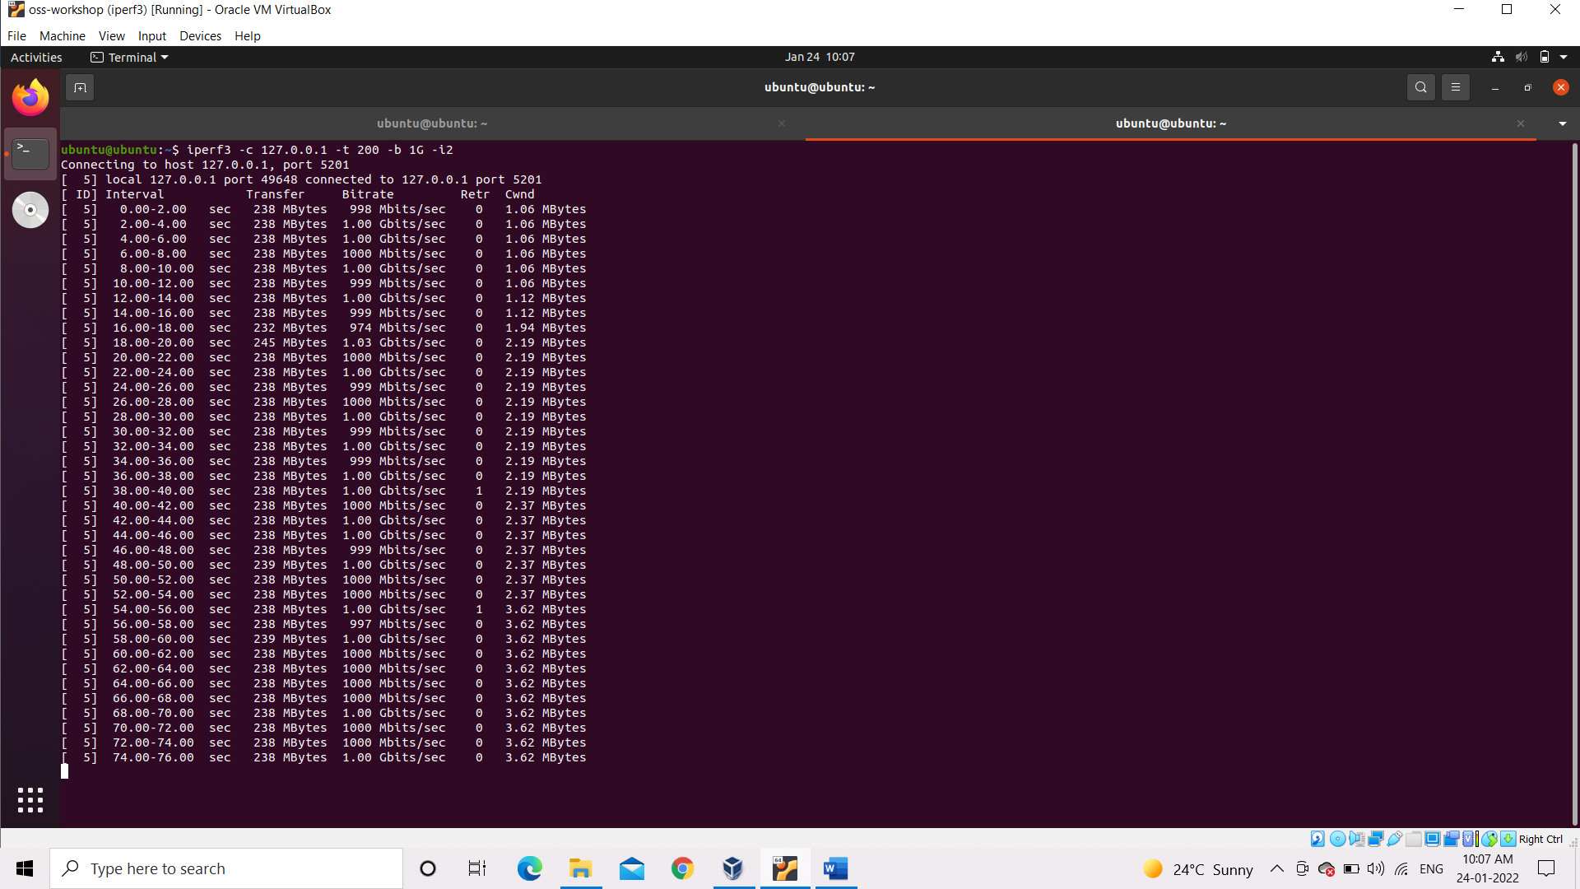

// c indicates client mode, 127.0.0.1=Ip address, -t represents time, -b represents bandwidth.

//Sample Output

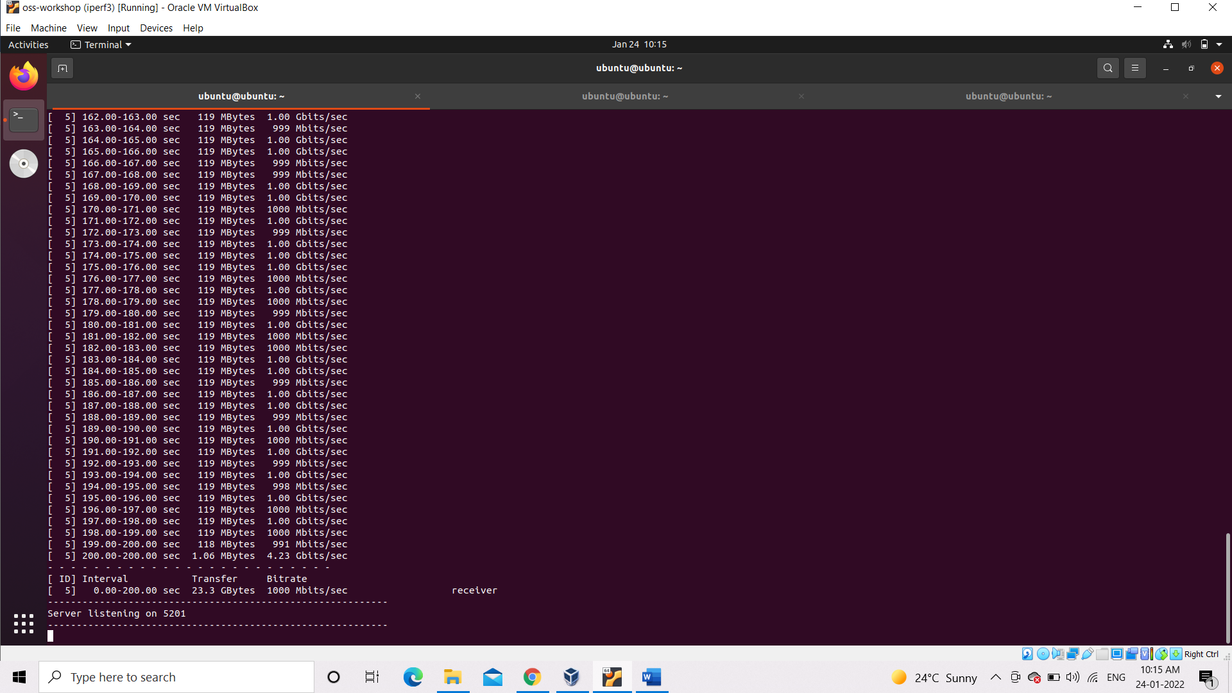

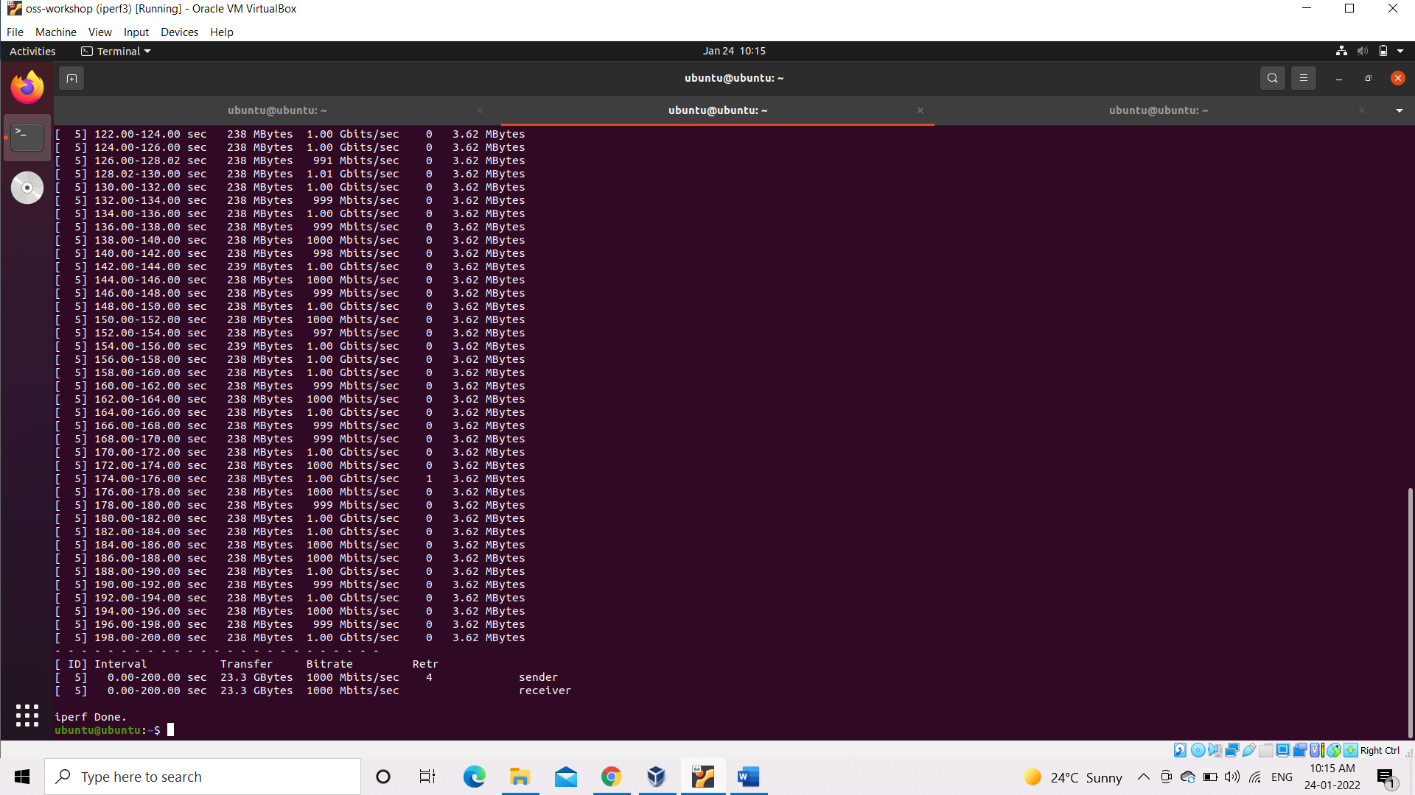

//Visual data of Network in InfluxdB after using iperf3.

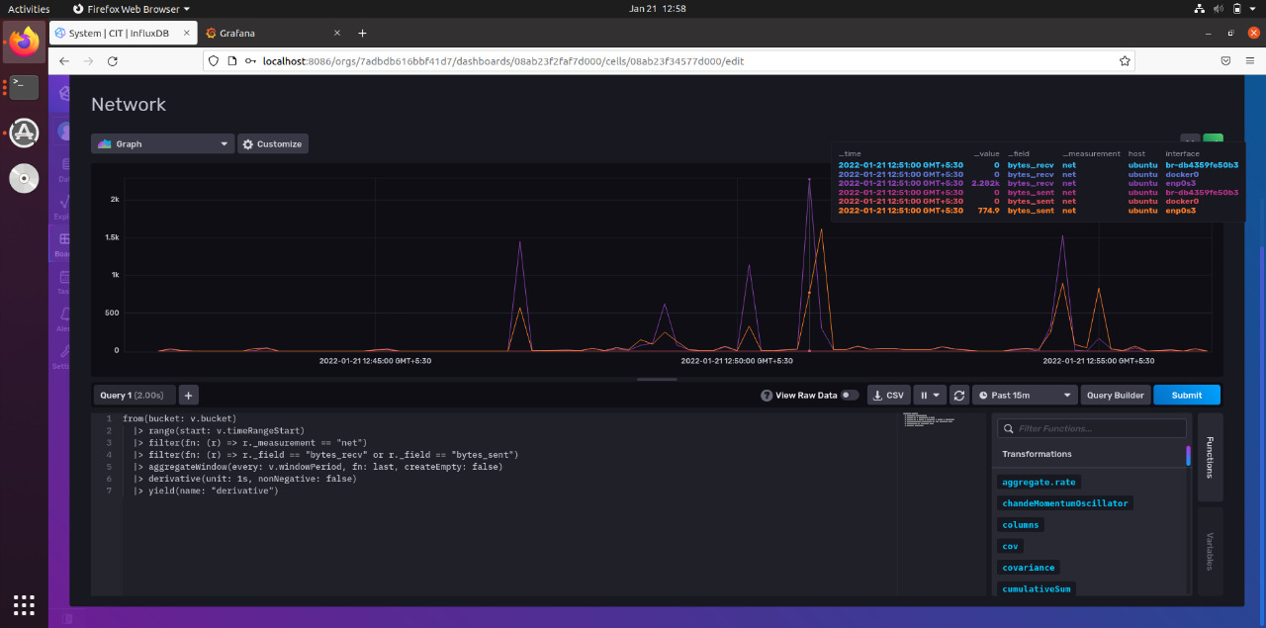

//1. stress – is a workload generator tool designed to subject your system to a configurable measure of CPU, memory, I/O and disk stress.

2. stress-ng – is an updated version of the stress workload generator tool which tests your system for following features:

* CPU compute
* drive stress
* I/O syncs
* Pipe I/O
* cache thrashing
* VM stress
* socket stressing
* process creation and termination
* context switching properties
* Though these tools are good for examining your system, they should not just be used by any system user.

//running stress command

Uptime

sudo stress --cpu 2 -v -t 20s

uptime

//Sample Output (check the uptime before and after using the stress command)

